My Precious Satanists
December 10th, 2021

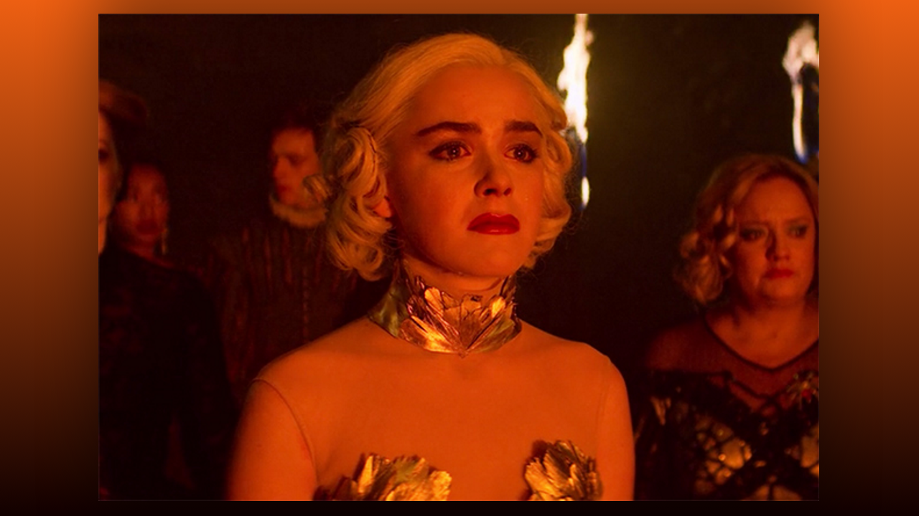
Lord, what do you want to say to Heart Dwellers and those in the world who are looking for security and peace at this time?

Jesus continued, “My precious, precious people...when I say precious, I am also addressing all of you in Satanic cults, all of you hurting children and siphoning off their blood, I hate what you are doing to My little ones, but I love you dearly. I want you to know that whatever crime you have committed, I will take you into My arms and welcome you into My kingdom, with special protection from Satan and your coven, if you repent of the things you have done. Yes, I love you, yes, I died for you on the cross, and I will never stop praying for you and begging mercy so that you do not perish with the fallen angels. Please, in difficult moments, remember, I love you too, not just the ones following My laws, but I love and am deeply concerned for you. I wait for you to come to Me and My true Christian people are praying for you daily.

So to continue, My precious people, there will be no peace on this earth until I return for the thousand year reign. This is a literal reign, not symbolic, as some scholars mistakenly believe. You are now in the time frames of the coming tribulation. You are now seeing many things that have been hidden from you before, because soon the world will be taken over by Anti-Christ.

Your only security and peace is in Me. Confess your wrong doing daily, ask for My pardon and strength to avoid those sins in the future, and dedicate your life to Me. It is written that those who lose their lives for My sake will gain them. Those who hold onto their lives and refuse to repent will lose even what they have and not for a specified amount of time, but for eternity. Just like Heaven is eternal, so is Hell. I did not create that place for you but for the angels who rebelled against My Father. By the way, Satan is no brother of Mine. He was the angel that directed worship to My Father until pride and jealousy took him over and he fell, taking with him a third of the foolish and deceived angels. So, I created a special place of torment by fire and ice for them. I NEVER wanted My children to go there, but because of free will choices, too many have ended there. It grieves My heart, but the grief and torment they experience because they believed Satan's lies about a kingdom, is the greatest tragedy a human can suffer.

You who have chosen the torments of Hell as your final resting place, do you really believe what the Father of lies has taught you? Listen children, you are filled with bitterness, hatred and fear, aren't you tired of living this way? What if all of that was removed from your heart and for once in your life you felt peace, security, and deeply loved by the God who knows when you sit and when you stand? What if all your past pain could be erased and replaced with joy and expectation of a fresh start in life? What if all the secret desires of your heart, to become an athlete, artist, musician, teacher or one who defends justice and makes a difference in the world could come true? What if there was a way out of where you are now? Would you take it?

What if you could see the fulfillment of deep hidden dreams of things you have always wanted to do?? What if, you were born again, into a place where love, patience, kindness, appreciation, respect and honor, were a way of life?

No church or Christian group is perfect, but there are some that truly live by these laws and they have no prejudice for race, color or past crimes. They love and respect one another equally. They support the dreams of their friends; they give of their time and talent to help you to heal from the past and advance into a future that has meaning. A place where bitterness, fear and anger, are not the daily routine. There are places like that. There are people like that that genuinely care about you and what your future holds. They want to see you healed and on your way to a life with a real future that satisfies your deepest desires. There are people like that in My kingdom and they are praying for you to be set free from hatred, rage, and bitterness.

Jesus continued, "Come to Me, let Me prove My love for you. Repent of the wicked things you have done and give me free reign in your life. I will lead you into that dream. There is hope, yes, even for you who have murdered babies and drank their blood. Yes, I will forgive you, yes, I still love you and will never give up calling you to myself. Remember this in your darkest hour...call Me and I will be there.

